Stottesdon and Sidbury Parish Council

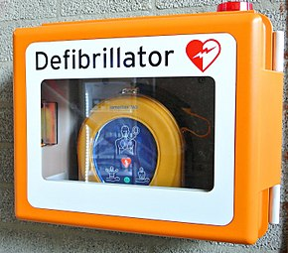

Would you like to know how to use the defibrillator in an emergency?

Training has been arranged by the West Midlands Ambulance Service for

Friday 24th May 2019

in

Chorley Village Hall
7 – 8.30pm

If you would like more details (or would like to book a place) please ask at the Surgery
or contact
Parish Council Clerk
Freda Morris – 01746 718453

