Stottesdon and Sidbury Parish Council

The Annual Parish Meeting will be held at Chorley Village Hall on Monday April 17th at 7.30pm.
Local Government electors for the Parish will be entitled to vote at the meeting which will be open to the public (LGA 1972, ss13(1) and 32 (1)

This is the meeting of the Parish, and all parishioners are welcome to attend and find out what is going on where you live and put new ideas forward for consideration.
.
Tea and coffee will be served.

Guest speaker will be:
Ben Walker, Shropshire Council Senior Project & Engagement Officer, Connecting Shropshire, Economic Growth.

Agenda:
00. Chairman’s welcome and introduction of guest speaker:
01. Apologies
02. Minutes of last meeting – May 16th, 2022
03. Matters arising from minutes:
04. Chairman’s Annual Report
05. Shropshire Councillor’s reports
06. Organisation reports:
a) Stottesdon School/Nursery
b) Chorley Village Hall/Show
c) South Wheatland Archive Group (SWAG)
d) WI
e) Nightingale Nurses
f) Stottesdon/Sidbury Church
g) Chorley Chapel
h) Lengthsman Scheme
07. Parish problems
08. Kings Coronation
09. Chairman’s closing comments
10. Date of next meeting – 24th April 2023 (Parish Council meeting)

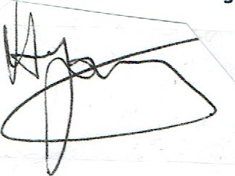
David Young - Chairman

